**Common barriers to vaccination and Suggestions**

(steal intro outline from [this post](https://delphi.cmu.edu/blog/2020/12/13/are-masks-widely-used-in-public/))

* Since the vaccines were authorized in [month], we’ve been trying to vaccinate everyone who is eligible in the US
* Early on, vaccines were only available to certain groups; in May 2021, they became available to everyone; but vaccine uptake has not been as high as initially hoped
* Using CTIS, we ask many people whether they’re vaccinated and why not; we can use this to explore why people are unvaccinated and how we could get them vaccinated
* (a reference to the vaccination questions and logic flow)

Since the vaccines first were authorized in December 2020 to healthcare workers, we’ve been trying to vaccinate everyone who is eligible in the US. Early on, vaccines were only available to certain groups; 2 months later, Covid-19 vaccines became generally available across the US, and by May, President Biden announced that they were widely available and everyone should get them.

However, despite all that, many people were still not vaccinated by May, and vaccine uptake has not been as high as initially hoped. And that’s why, through its COVID-19 Trends and Impact Survey, the Delphi Group started to track COVID vaccination barriers to help understand the vaccination barriers by vaccination status and age groups.

(delphi tries to understand, not exactly promotion)

Since May 20th, 2021, we have asked all respondents whether they have experienced specific barriers to getting the COVID-19 vaccine based on their vaccination status. We hope, through this article, we can give more insightful ideas and suggestions on why people are unvaccinated and how they can enable helping potential vaccinees get vaccinated.

**Common barriers in May 2021**

Let’s start with the common barriers to vaccination on May, 2021 by vaccination status. First, we ask respondents whether they have been vaccinated or not, and according to their vaccination status, they will be given a list of 12 or 13 specific barriers. Respondents can select multiple reasons, so the numbers do not add to 100%. Also, we ask unvaccinated people if they've tried to get vaccinated, and if the answer is no, we don't ask them about barriers.

This may explain why there are so few unvaccinated people in the table below: many unvaccinated people had not tried to get vaccinated. The huge sample size disparity between the vaccinated and the unvaccinated could possibly affect the accuracy of the measurement of the barriers for all respondents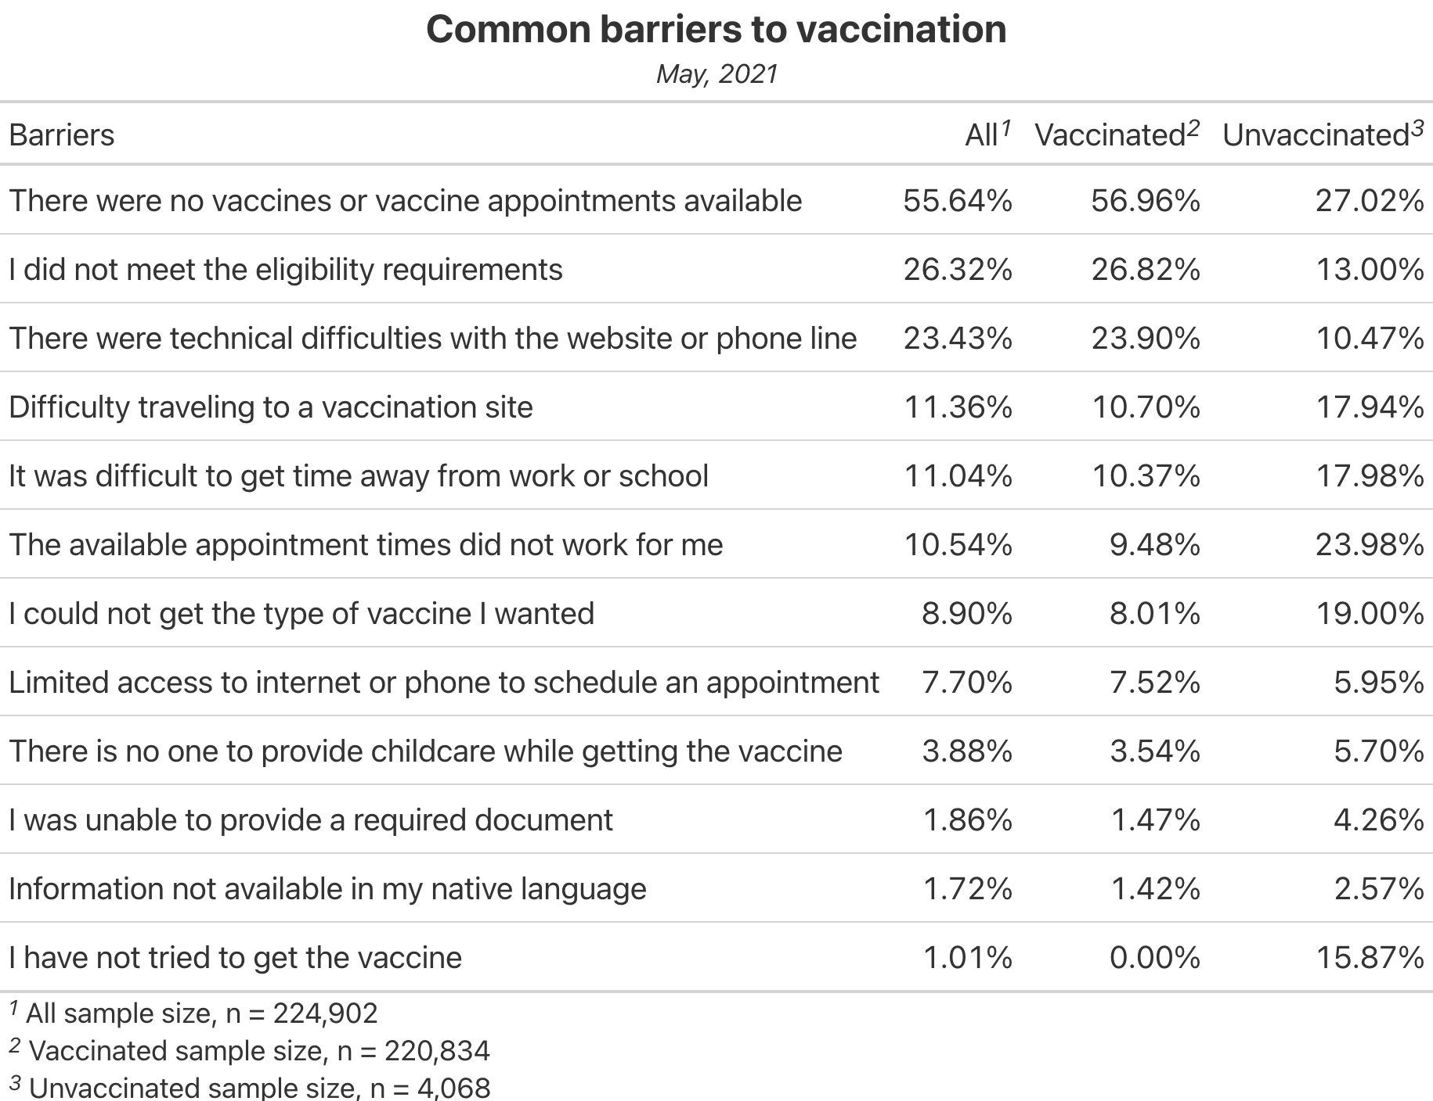

(Table 1. May 2021)

As you can see, there are similarities and differences between the common barriers to vaccination for the vaccinated and the unvaccinated. “There were no vaccines or vaccine appointments” is the top selected barrier for both. Nevertheless, the other two top reasons commonly selected by the vaccinated are eligibility requirements and technical difficulties, while the unvaccinated most often say the available times didn’t work or they could not get the type of vaccine they wanted, which is unexpected for us. What is noticeable is that “I have not tried yet” barrier also stands high among the unvaccinated. This is what we would expect to happen in normal circumstances: As more people get vaccinated, the people who remain unvaccinated are those who either don’t want to be vaccinated or haven’t yet been able to.

## Changing barriers over time

But these numbers don’t tell the whole story. It’s also very insightful to look at the time trend plot for barriers. The common barriers to vaccination varied throughout the past half year with the announcement for boosters, new policies, the larger population of the vaccinated and so on. In order to have clearer overview on the changes, we plot the trend for the barriers to vaccination for the vaccinated from May, 2021 to February, 2022, and two major discoveries are spotted:

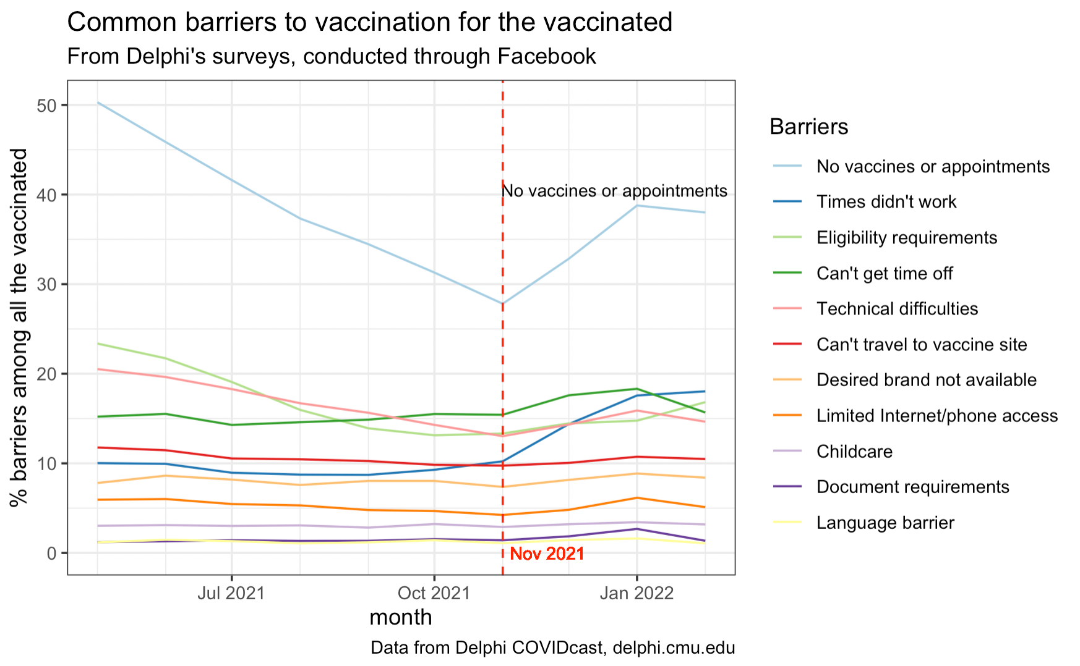

(Figure 1. All Vaccinated)

First, as we have noticed in the previous May 2021 table, for the vaccinated, “No vaccines or appointments” stands out from all the other barriers, and the percentage is twice as high as the second high barrier “Eligibility requirements”. Second, November 2021 seems to be an important turning point for many barriers, which is especially obvious for “No vaccines or appointments”. The explanation we have is, on November 19, 2021, CDC expanded eligibility for COVID-19 booster shots to all adults, so demand for vaccination appointments rose, making it harder for some people to get appointments.

https://www.cdc.gov/media/releases/2021/s1119-booster-shots.html

## Barriers experienced by each age group

Since we also ask respondents about their age groups, to have a more in-depth idea on how each age group was affected by different barriers, we divide our recipients into 4 age groups: 18-24, 25-44, 45-64 and over 65.

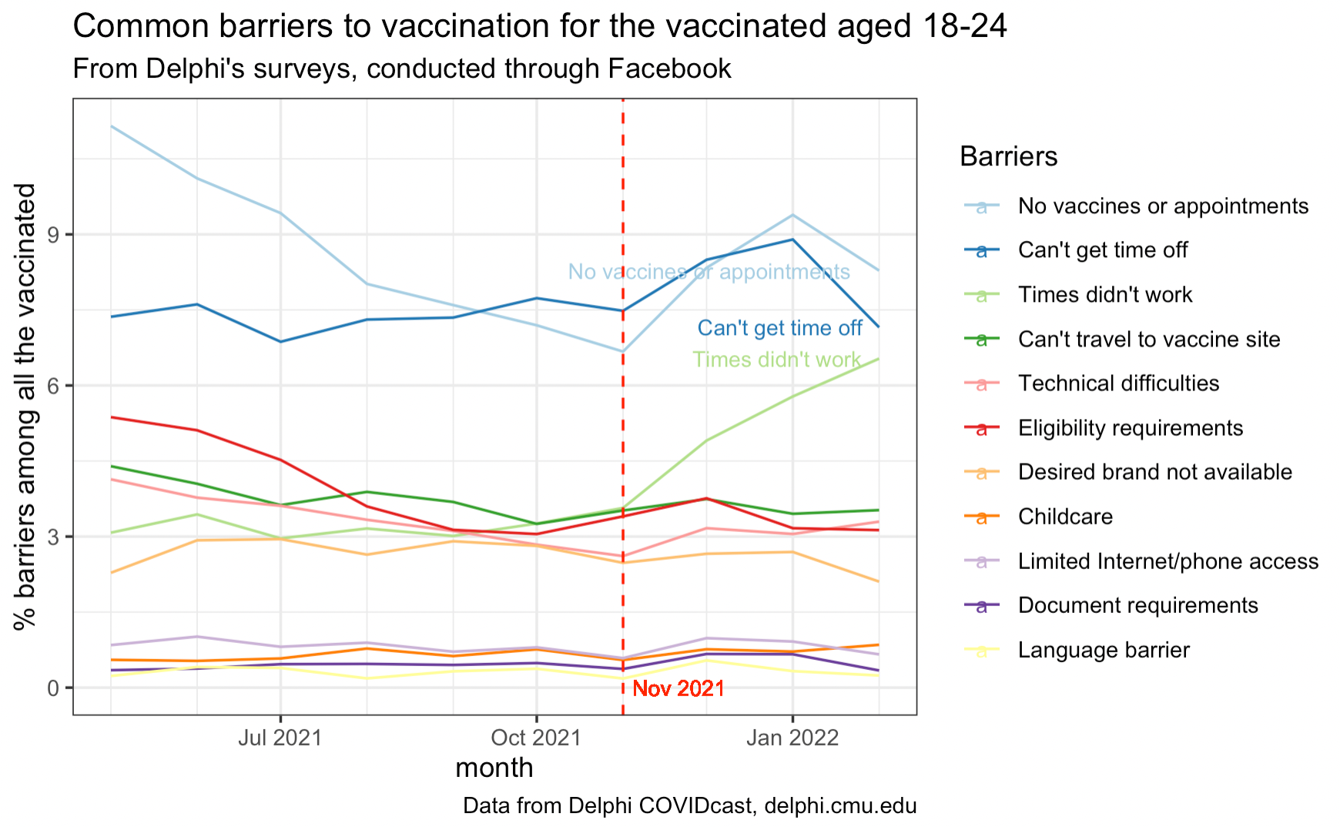

(Figure 2. Vaccinated 18-24)

For the age group 18-24, consistent with the all vaccinated, November 2021 is also a turning point for many barriers, which is obvious for top 3 barriers: “no vaccines or appointments”, “can’t get time off” and “time didn’t work”. This is understandable, because many in this age group are students or hourly workers, and their time is less flexible. To look more closely, both “no vaccines or appointments” and “time didn’t work” barriers have increased a lot since November 2021, suggesting it is important to increase vaccination capacity when boosters are introduced. Since 'can't get time off' remains high throughout, this suggests that adding more flexible “vaccination” time-off for hour-based workers and students should be considered to raise vaccination rate in the long term.

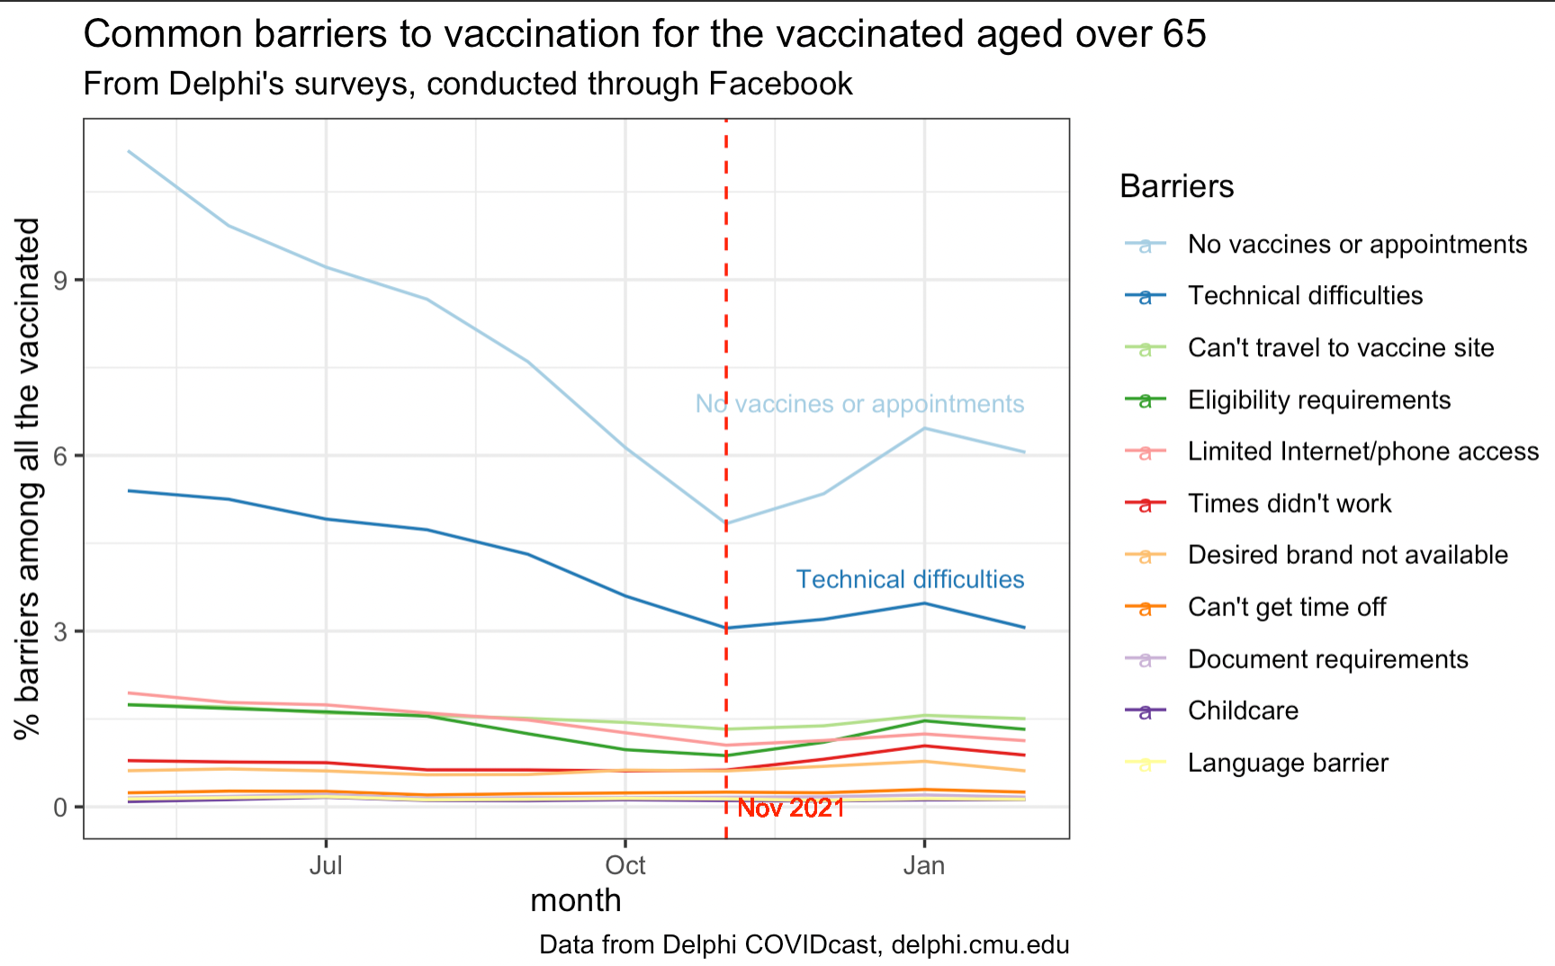

(Figure 3. Vaccinated over 65)

Also consistent with the all vaccinated, in the age group over 65, November 2021 is also a turning point for many barriers, indicating the introduction of boosters also caused changes in the age group over 65. Given the top selected two barriers align with what we expected, this age group will experience trouble making appointments online for vaccination. (Another possible explanation for this is that the releasing time at the start period of online appointment for vaccination is usually 12a.m., which is not an ideal time for people who is over 65). Though “technical difficulties” decreases a lot from May to February, but it still remains to be a major problem compared with other barriers. Thus, we suggest provide more convenient vaccine appointments/ services for people aged over 65.

As mentioned in the very beginning of the article, cases for the unvaccinated can be different from the vaccinated. Since the most barriers of the unvaccinated just fluctuate, instead, look just the most recent data collected on January 2022 as below:

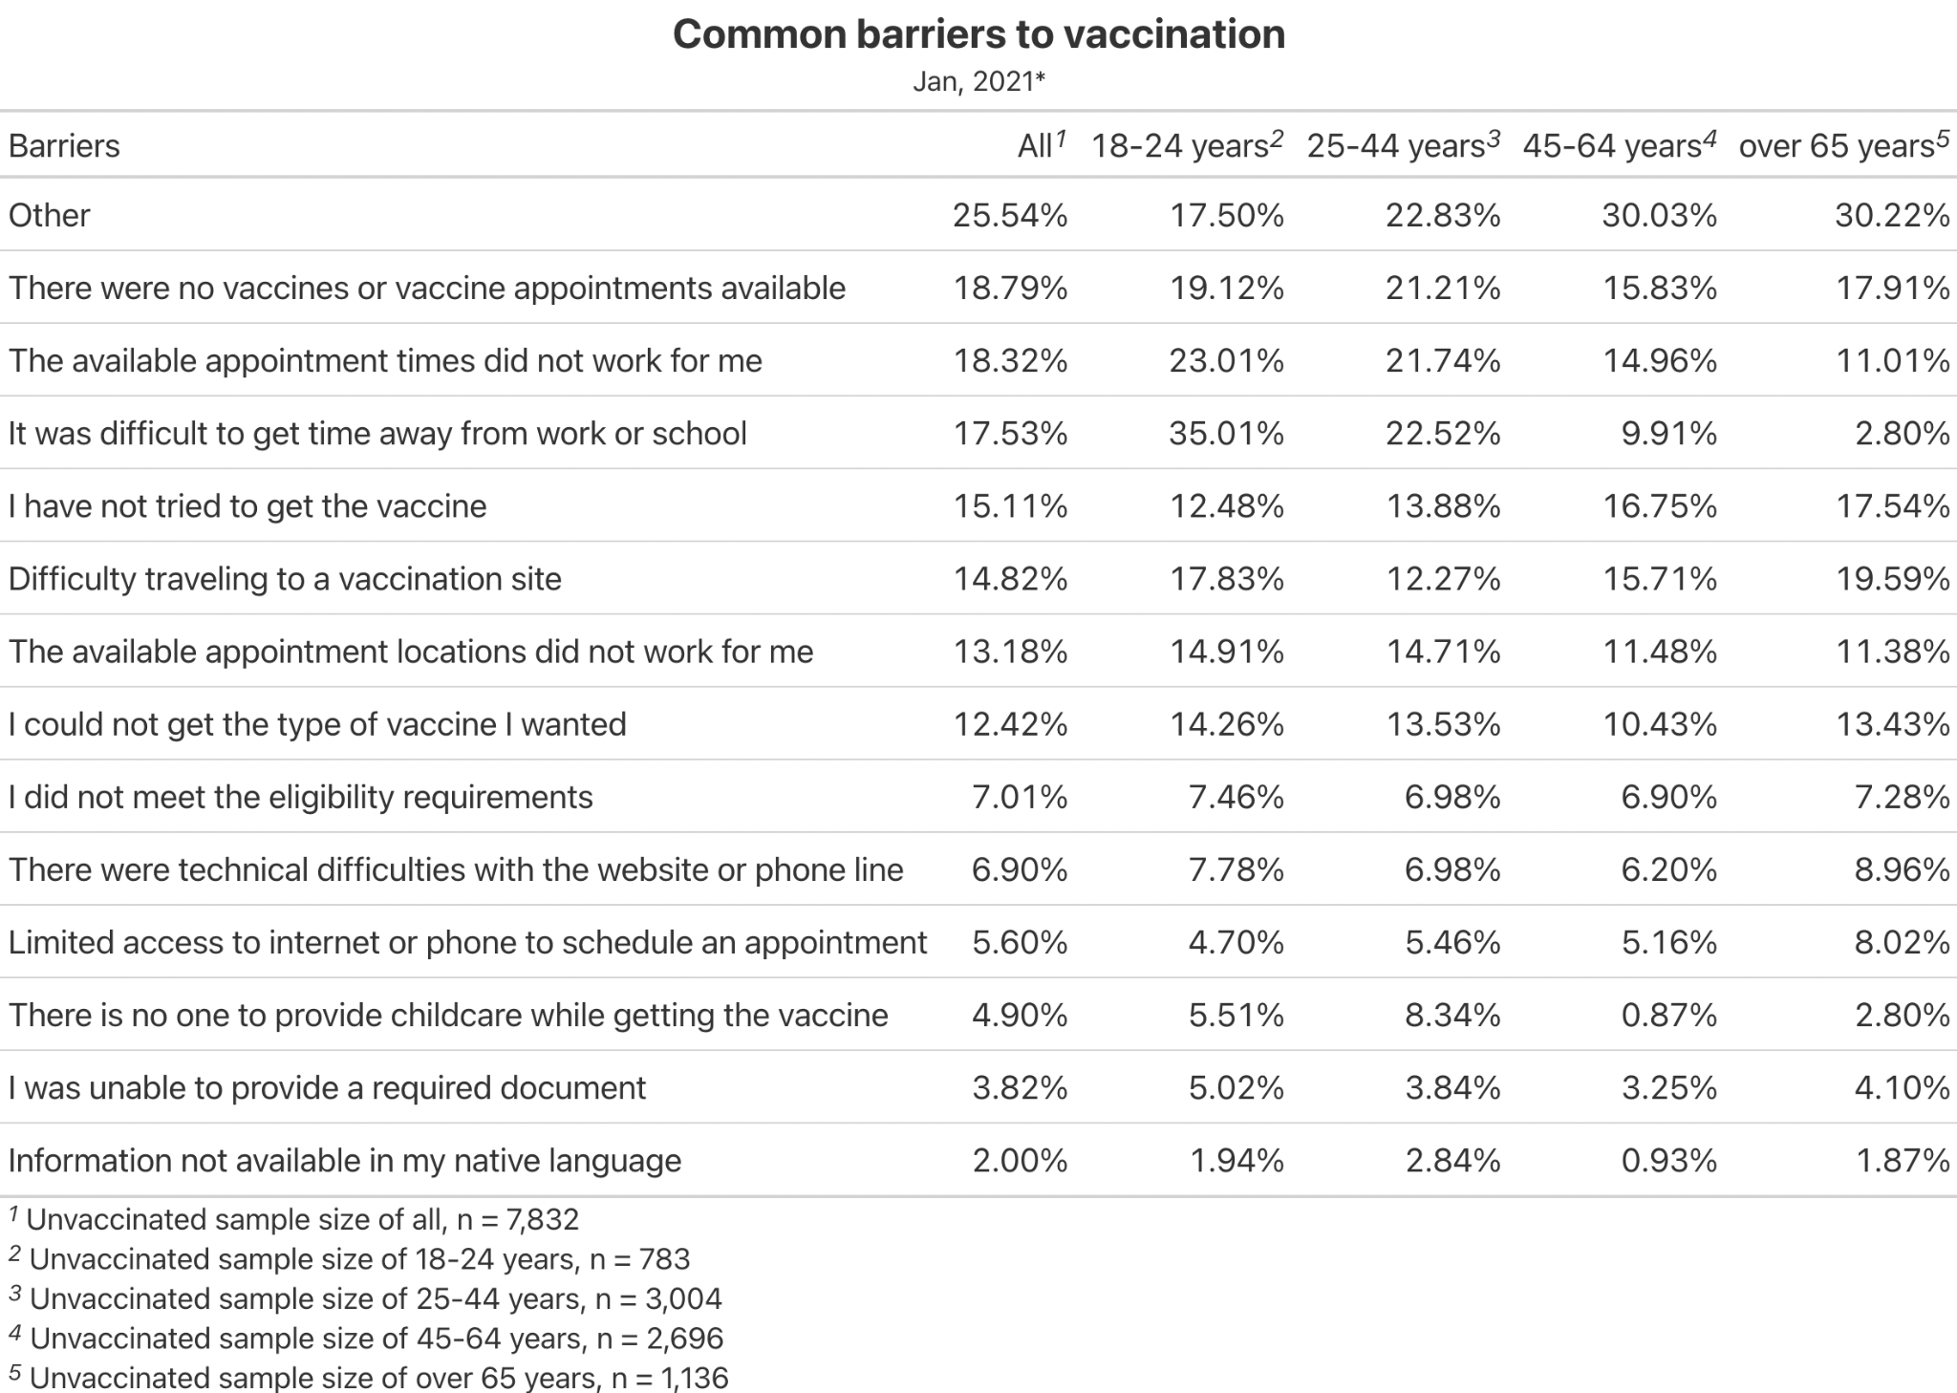

(Table 2. Jan 2022)

The picture is very consistent across all unvaccinated age groups. Aside from “other” and “have not tried yet”, the most common barrier for people aged 18-44 is getting time off of work, while for people aged over 45, it's traveling to the vaccination site. In addition to providing more available vaccination services for more sites, we also suggest distribute evenly vaccination supplies of different brands and provide more choices for potential vaccine recipients, noting that “desired brands not available” exceed 10% across all age groups.

## Limitations

As with any scientific study, there are limitations to the results seen above. Here are a few important things to keep in mind:

* **We’re surveying Facebook users.** While we [weight survey responses](https://arxiv.org/abs/2009.14675) to ensure their age and gender distribution matches the United States population, our respondents do tend to be more educated than the national average, which the weights do not correct for.
* **The survey is voluntary.** Facebook draws a random sample of active users every day and invites them to take the survey via a promotion in their News Feed. Many people don’t respond to the invitation, and while the Facebook-provided survey weights attempt to account for this by using models to predict the probability each user will respond, there may still be unobserved biases remaining.
* **The sample size gap cannot be ignored.** The survey overrepresents vaccinated people. Compared to official CDC data, the survey estimate of the number of Americans vaccinated in early 2021 is too high. As a result, the rates of barriers reported by our respondents may not match the rate experienced by the overall American population.
* **Survey responses are simplifications.** Our respondents can select barriers from a list, but ticking boxes can’t fully represent the complexity of their beliefs and the other realistic reasons that may affect their actions. Also, their responses may not always match their behavior: a respondent who says they “have not tried yet” to get vaccinated may decide to get vaccinated when a desired brand dose is offered to them.

## Conclusions

Based on the vaccination barriers of survey responses from hundreds of thousands of Facebook users, we divide them by two vaccination status and four age groups. While there is disparity between the vaccinated and the unvaccinated, the most common barrier for both is no vaccines or appointments available, and the scenario remains the same from May 2021 to February 2022 among all the vaccinated age groups. This may suggest we should take extra efforts to ensure access to vaccines for potential vaccine recipients. On the top of that, November 2021 appears to be a turning point, since then, the percentages for many barriers have raised. Noting it is when the eligibility for COVID-19 booster shots expands to all adults, the demand for vaccination appointments will increase. Extra availability for vaccination and service may need to be be ensured whenever a new dose is introduced.

To take a closer look, for the vaccinated people who are between 18-24 years old, “time didn’t work” and “can’t get time off” stand high among the barriers, while for the vaccinated aged over 65, “technical difficulties” has diminished considerably but remains relatively high. There are no magic solutions, but as CDC has already suggested, (<https://www.cdc.gov/vaccines/covid-19/health-departments/generate-vaccinations.html#:~:text=Partner%20with%20local%20community%20groups,or%20request%20at%2Dhome%20vaccinations>) we are suggesting offering more “vaccination time-off” for students and time-based workers, and offering more convenient vaccine appointments/ services for priority populations like people aged over 65.

Nonetheless, different from the vaccinated, among all the unvaccinated age groups, the most common barrier is desired brands not available. Thus, we propose evenly distribute vaccine supplies between different brands to provide diverse options for potential vaccine recipients.